**Accounting And Financial Analytics Assignment – 3**

**Title :–** **Analyzing Competitive Advantages**

**In Real Companies**

**Contents:**

1. Introduction
2. Background Information
3. Competitive Advantages
4. Financial performance Evaluation
5. Comparative Analysis
6. Assessment of sustainability
7. Conclusion

**Introduction**

**Technology Sector –: *Meta***

Meta is an American Multinational technology conglomerate based in Menlo Park, California. The Company owns and operates Facebook, Instagram, Threads, and WhatsApp, among other products and services. Meta was founded by Mark Zukerberg, who is also a chairman and CEO of Meta, which he originally founded as Facebook in 2004.

Meta platform is a highly profitable multinational technology company. Meta has linked the new brand name to his strategic plans to create a metaverse a virtual world in which consumers spends increasing part of their lives based on AI and virtual reality (VR) technology.  Now, Meta is moving beyond 2D screens toward immersive experiences like augmented, virtual and mixed reality to help build the next evolution in social technology.



**Consumer Goods Sector** -: ***Nike***

Nike is an American atheletic footwear and appreal corporation headquatered near Beaverton, Oregon, United States It is world’s largest supplier of atheletic shoes and apparel and a major manufactured of sports equipment, with revenue of axcess US$46 Billion in its fiscal year 2022. It was founded on January 25, 1964, as “Blue Ribbon Sports”, by Bill Bowerman Phil Knight, and officially Inc. on May 30, 1971. The company takes its name from Nike, the Greek goddess of victory. Nike markets its products under its own brand, as well as Air Force, Nike CR7, Air Jorden, etc.

Air Jordan is a line of basketball shoes produced by Nike, Inc. Related apparel and accessories are marketed under Jordan Brand. The first Air Jordan shoe was produced for basketball play Michael Jorden during his time with the Chicago Bulls on November 17, 1984 and released to the public on April 1, 1985.

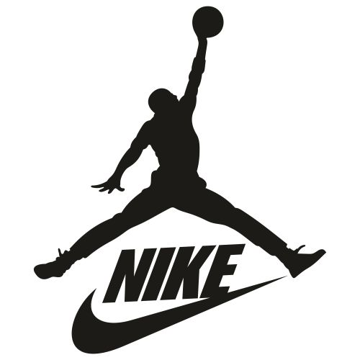

**Background Information**

***Meta :***

Meta ranks among the largest American information technology companies, alongside other Big Five corporations Alphabet(Google), Amazone, Apple, and Microsoft. The company was ranked #31 on the Forbes Global 2000 ranking in 2023. Meta Platforms, Inc. January 4, 2004 in Cambridge, Massachusetts, U.S.

Meta Platforms, formerly known as Facebook, was founded by Mark Zukerberg along with fellow students at Harvard University in 2004. Initially, the website was exclusively for Harvard students, but soon expanded to other universities, and eventually became available to anyone with an email address. In 2005, the company received its first major investment from venture capitalist Peter Thiel, and by 2006, it had over12 million registered users. In the same year, it introduced the News Feed. 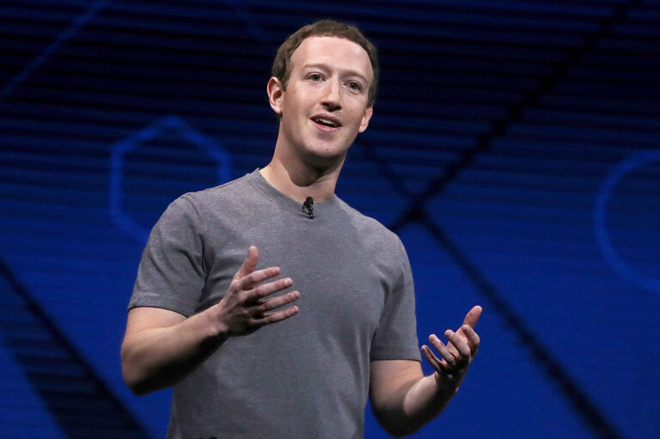

***Nike :***

By 1964, Knight and his former University of Oregon coach, Bill Bowerman, formed Blue Ribbon Sports, they created the iconic Tiger Cortez in 1967, their version of the Onitsuka Tiger. In 1971, Blue Ribbon split with Onitsuka; and the duo changed the firms name to Nike, after the Greek goddess of victory. Nike went public in 1980, but struggled until, in 1984, the company spent its entire marketing budget to sign ***NBA*** rookie Michel Jorden in an attempt to breath life into its basketball shoe division. Jordan signed a five-year, $2.5 million contract to promote the Air Jordan a black-and-red basketball shoe that initially sold for $65 for pair (equal to $192 in 2023 dollars).

The Nike/Michel Jordan contract changed how brands sign athletes and other celebrities to marketing deals, as well as how brand market themselves. The National Basketball Association **(NBA)** banned Jordan’s shoe, and issued a $5000 fine each time he wore them. Nike embraced the ban and the controversy surrounding the shoes. The company paid the fines on Jordan’s behalf and created ad campaigns around the ban, saying, “The NBA can’t stop you from wearing them.” Within the first two months of the shoe’s release, Nike sold $70 million worth of Air Jordans. By the end of 1985, the firm reported revenue in excess of $100 million.

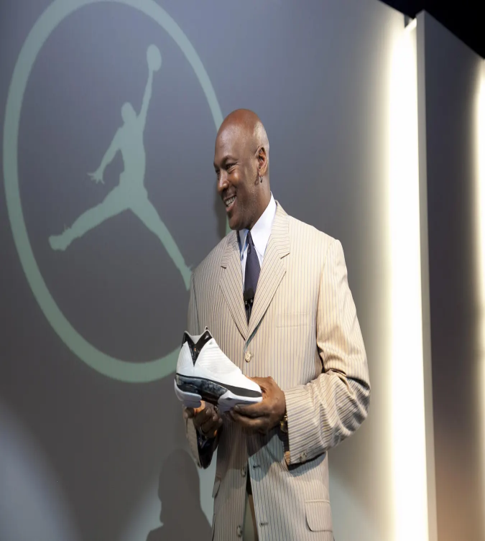***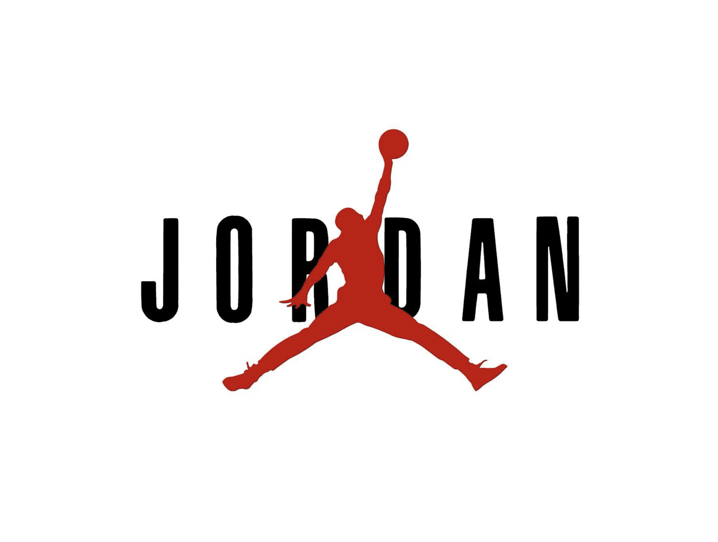*Competitive Advantages**

***Meta :***

1. **Brand Reputation** : The reputation of Meta may very depending on whom you ask and the context in which its discussed. Some people might view Meta positively for its innovative technologies and potential to shape the future of human interaction. Overall, Meta’s reputation is a complex mix of admiration of its technological achievements and criticism of its ethical and societal implications. As of 2024, its likely that Meta continues to navigate these challenges.
2. **Market Leadership** : Here are some key points of Meta’s market leadership : a) Social Media => Facebook, acquired by Meta Platforms, remains one of the most widely used social media platforms globally. With over 2.8 billion monthly active users as of 2021, Facebook dominates the social networking space. b) Instagram => Instagram, acquired by Facebook in 2012, has also grown into one of the leading social media platforms, especially popular among younger demographics. Its user base exceeds one billion monthly active users. c) WhatsApp => WhatsApp, acquired by Facebook in 2014, is one of the most popular messaging apps globally, with over two billion monthly active users. It holds a strong position, particularly in markets outside of the United States. d) Virtual Reality (VR) => Meta has made significant investments in virtual reality with its Oculus VR division.

Digital Advertising => Meta Platforms is a dominant force in digital advertising, thanks to its massive user base across Facebook, Instagram, and other platforms. It offers targeted advertising solutions that are highly attractive to advertisers looking to reach specific demographics.

1. **Technological Innovation :** The rebranding was largely tied to the company's shift in focus towards building the metaverse, a virtual reality-based successor to the internet. Mark Zuckerberg, CEO of Meta Platforms, outlined a vision for the metaverse as an interconnected virtual environment where people can interact, work, play, and create. This represents a significant technological innovation and AI technologies for virtual environments.



***Nike :***

1. **Brand Reputation :** The 2023 rankings are based on Harris' survey of more than 16,000 respondents in March. Nike's (NYSE: NKE) climb was the largest of any other company on the list, placing it in the “very good” category with an overall score of 78.4 out of 100, and with a brand awareness of more then 90% Nike Air Jordan is one of the most well-known sneakers brands in the United States, and 25% of sneakers owners in the United states own a pair of Jordans.
2. **Market Leadership** : Nike was one of the most prominent and influential companies in the global sportswear and athletic footwear industry, Here are several factors contributing to Nike's market leadership: a) Brand Strength => Nike has built an iconic brand that is recognized globally. Its swoosh logo is synonymous with athletic excellence and style, making it a top choice for athletes and consumers alike. b) Innovation => Nike continuously invests in research and development to innovate its products, from footwear to apparel and accessories. Technological advancements such as Nike Air cushioning and Fly knit material have helped the company stay ahead of the competition. c) Market Endorsements => Nike's marketing campaigns are often highly impactful, leveraging endorsements from top athletes and celebrities to promote its products. Partnering with athletes like Michael Jordan, LeBron James, and Serena Williams has bolstered its brand image and market reach. d) Global Presence => Nike has a strong presence in key markets worldwide, with retail stores, online platforms, and partnerships with distributors and retailers. Its extensive distribution network ensures widespread availability of its products. *“And also, Nike's Jordan brand is undoubtedly one of the most iconic and successful sneaker lines globally, synonymous with basketball culture and urban fashion. The combination of its rich heritage, innovative designs, strategic marketing, and cultural relevance has solidified the Jordan brand’s marketing leadership in the sneaker industry.”*
3. **Distribution Network** : In addition to selling directly to retailers, Nike also works with wholesalers distributers. These intermediaries help in moving large quantities of products efficiently. They often supply products to smaller retailers who might not have direct relationships with Nike.

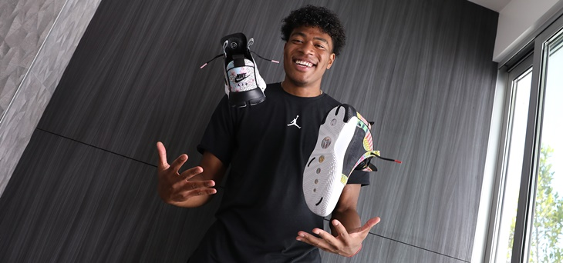 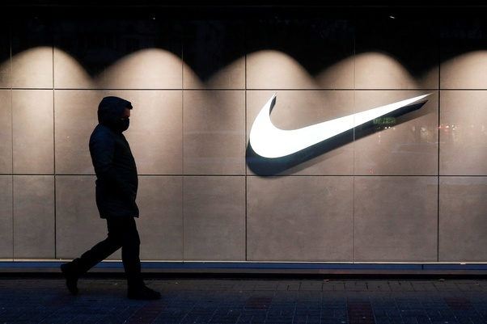

**Financial Performance Evaluation**

***Meta :***

The company’s EPS TTM is $14.896; its P/E ratio is 32.55; and it has a dividend yield of 0.10%. Meta Platform is scheduled to report earnings on April 23, 2024, and the estimated EPS forecast is $4.28. See an overview of income statement, balance sheet, and cash flow financials.

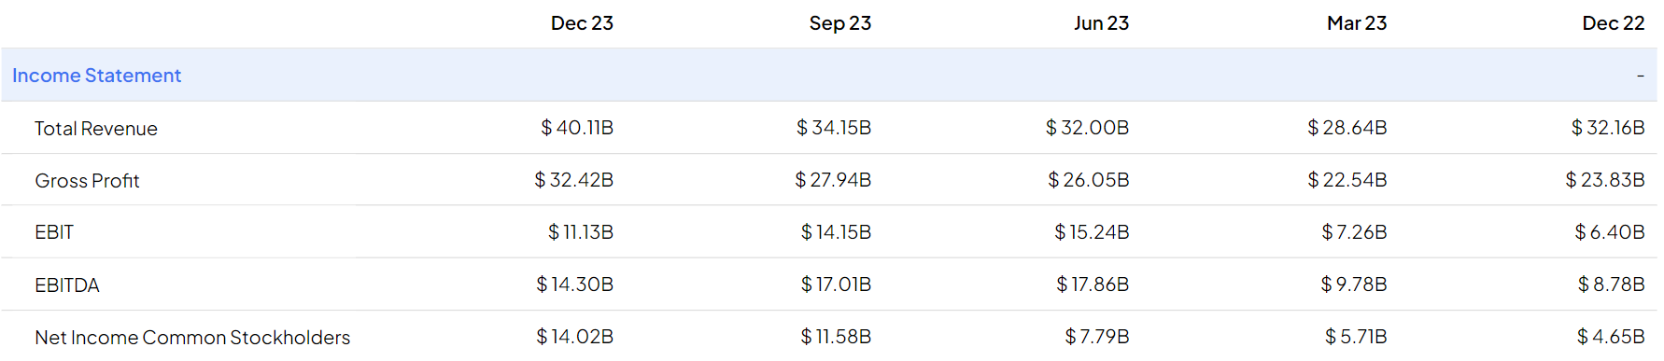

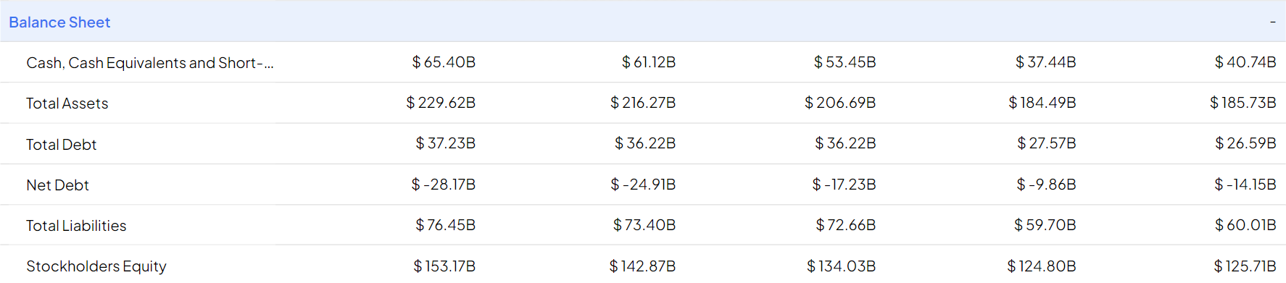

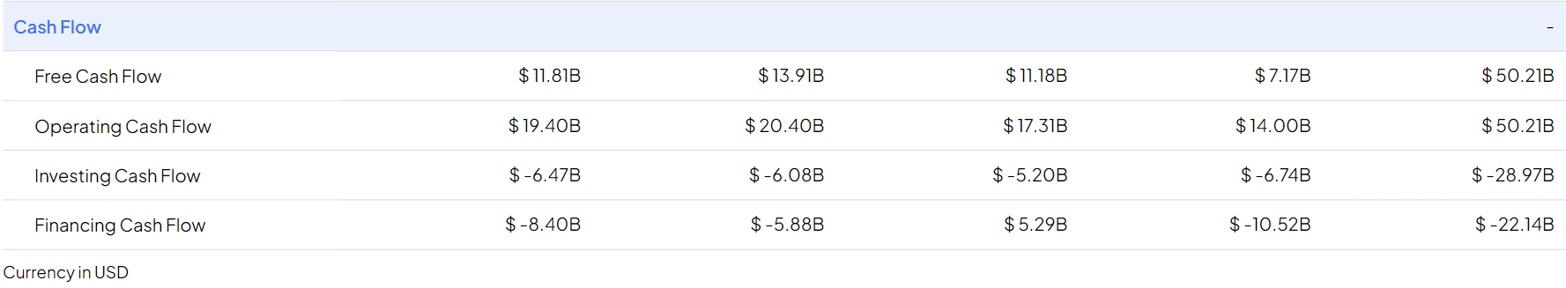

Free cash flow was $11.50 billion and $43.01 billion for the fourth quarter and full year 2023, respectively. Long-term debt – Long-term debt was $18.39 billion as of December 31, 2023. Headcount – Headcount was 67,317 as of December 31, 2023, a decrease of 22% year-over-year.

Meta platforms has a total shareholders equity of $153.2B and total debt of $18.4B, which brings its debt-to-equity ratio to 12%. Its total assets and total liabilities are $229.6B and $76.5B respectively. Meta Platforms EBIT is $50.2B making its interest coverage ratio -42.1.

***Nike :***

Nike, Inc. reported earnings results for the second quarter and six months ended November 30, 2023. For the second quarter, the company reported sales was $13,388 million compared to $13,315 million a year ago. Net income was $1,578 million compared to $1,331 million a year ago.

Basic earnings per share from continuing operations was $1.04 compared to $0.85 a year ago. Diluted earnings per share from continuing operations was $1.03 compared to $0.85 a year ago. For the six months, sales was $26,327 million compared to $26,002 million a year ago. Net income was $3,028 million compared to $2,799 million a year ago. Basic earnings per share from continuing operations was $1.99.

compared to $1.79 a year ago. Diluted earnings per share from continuing operations was $1.97 compared to $1.77 a year ago.

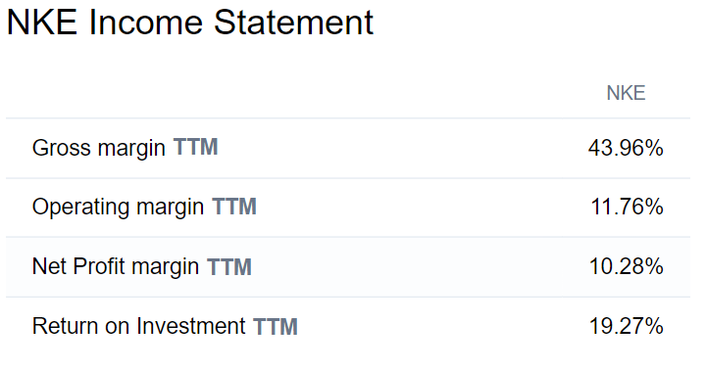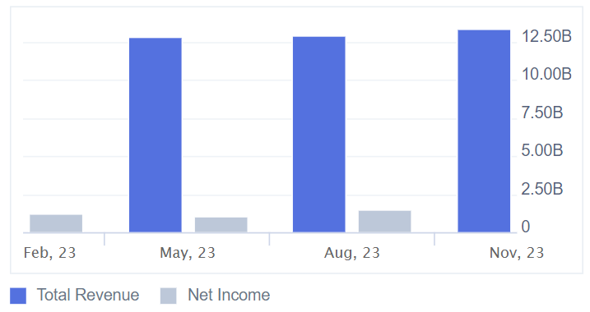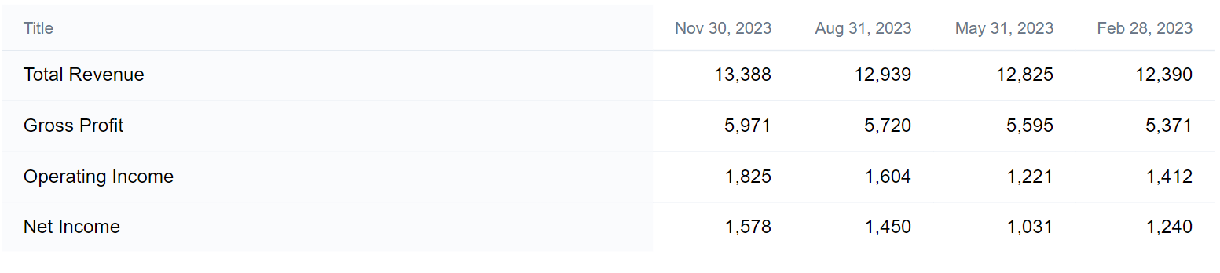

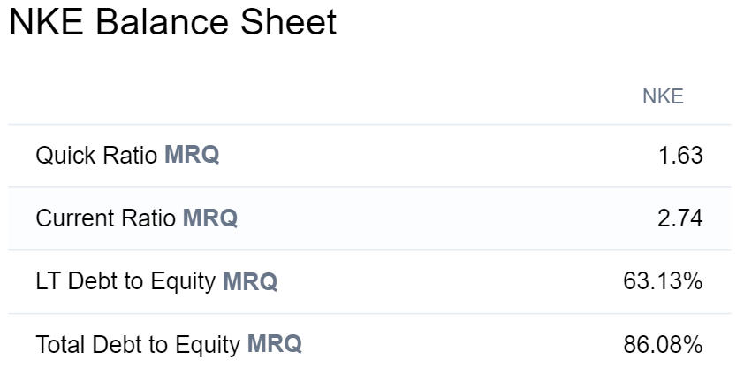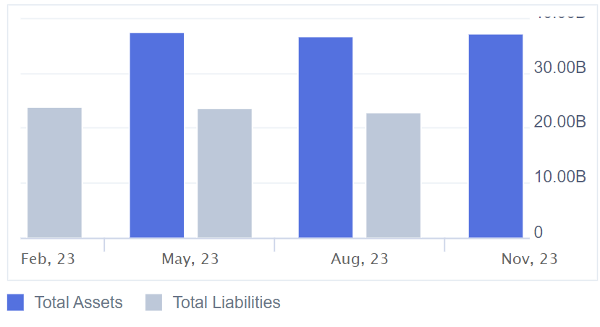

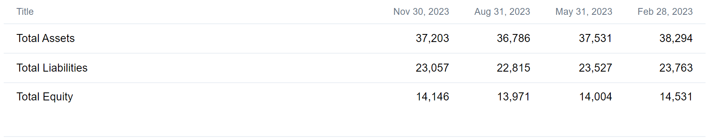

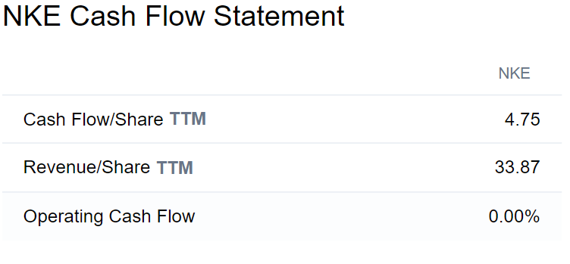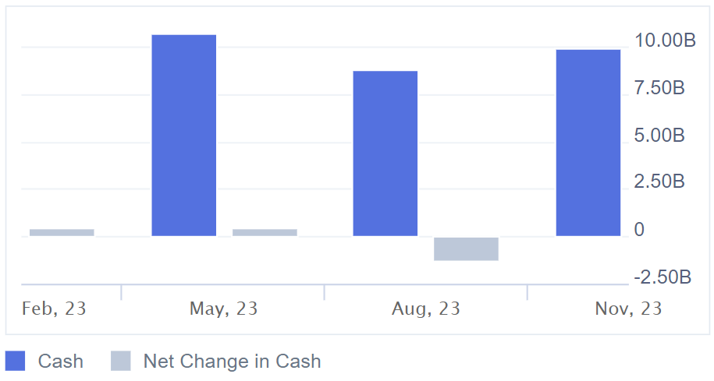

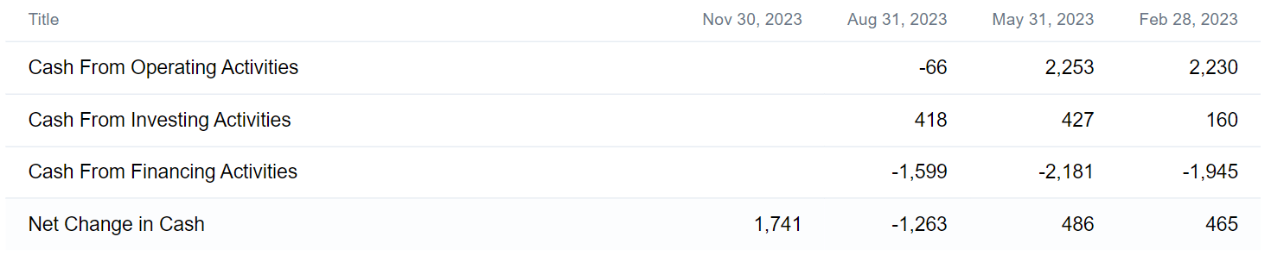











**Comparative Analysis**

***Meta :***

1. **Market Share :** Meta Platforms, formerly known as Facebook, was one of the leading companies in the global social media market. Facebook, along with its subsidiaries such as Instagram and WhatsApp, held a significant portion of the market share in terms of active users and advertising revenue. Due to strong revenue growth of 24.71% in Overall company Meta Platforms Inc improved its market share, to approximately 24.73%. More on Meta Market Share. Market share is calculated based on total revenue.
2. **Growth Prospects :** “Earnings Growth” While the historical EPS growth rate for Meta Platforms is 17.1%, investors should actually focus on the projected growth. The company's EPS is expected to grow 34.1% this year, crushing the industry average, which calls for EPS growth of 23.9%. The 41 analysts with 12-month price forecasts for Meta Platforms stock have an average target of 434.41, with a low estimate of 609. The average target predicts a decrease of -14.07% from the current stock price of 505.52.
3. **Competitive Threats :** a) *Competition In Social Media* - Meta's primary business is social media, where it faces competition from various platforms such as Twitter, Snapchat, TikTok, and emerging players. These competitors continually innovate to attract users and advertisers, challenging Meta's dominance in the social networking space. b) *Deta privacy and Security Concerns -* Meta has faced significant scrutiny over its handling of user data, leading to privacy concerns and regulatory actions. Competitors that prioritize data privacy and offer more secure platforms could attract users who are wary of Meta's track record in this area. c) *Regulatory Challenges -* Meta faces regulatory challenges worldwide, with governments increasingly scrutinizing its market dominance, data practices, and influence over online discourse. Regulatory actions could impose restrictions on Meta's business operations, impacting its competitiveness. d) *Sifts In User Behaviour -* Changes in user behaviour, such as a shift towards private messaging and ephemeral content, pose challenges to Meta's traditional social networking model. Competitors offering innovative features and catering to evolving user preferences could disrupt Meta's user base. e) *Ad Tech Competition -* In the digital advertising space, Meta competes with major players like Google and Amazon. These competitors have vast advertising networks and data analytics capabilities, challenging Meta's position as a leading digital advertising platform.
4. **Barriers To Entry** **:** Barriers to entry in the metaverse can be significant and multifaceted, including: a) *Technological Barriers -* Developing applications, platforms, and hardware for the metaverse requires advanced technological expertise. Creating immersive experiences demands knowledge of VR/AR technologies, spatial computing, 3D modelling, and more. This expertise can be a barrier for new entrants without the necessary resources or skills. b) *Infrastructure Requirements -* Building and maintaining the infrastructure needed to support the metaverse, including high-speed internet, servers, and data centres, can be costly. Access to robust infrastructure may be limited in certain regions, creating barriers for widespread participation. c) *Financial Resources -* Developing and deploying metaverse applications often requires significant financial investment. Funding is needed for research and development, software and hardware acquisition, marketing, and ongoing maintenance. Access to capital can be a barrier for startups and individuals with limited resources. d) *Intellectual Property and Content Creation -* Creating compelling content for the metaverse involves navigating intellectual property laws and licensing agreements. Developing original content or securing rights to existing content can be complex and expensive, particularly for small creators and independent developers. e) *Social And Cultural Acceptance -* Overcoming social and cultural barriers to widespread adoption of the metaverse is essential. Some people may be hesitant to embrace virtual environments due to concerns about privacy, identity, and the blurring of boundaries between the physical and digital worlds.

***Nike*** ***:***

1. **Market Share :** Nike holds a 38.23% total market share. With a market capitalization of $197.8 Billion, Nike is among the 50 most valuables companies in the world. Nike stats show that its still the most popular sports brand in the world.
2. **Growth Prospects :** Nike’s revenue growth forecast is expected to average 5.4% over the next 5 fiscal year. Nike’s is expected to deliver median revenue growth forecast of 6.3% over the next 5 fiscal years. The economic conditions, consumer trends, and global events can impact Nike's growth prospects in unpredictable ways. Investors and analysts closely monitor these factors to assess the company's future performance.
3. **Competitive Threats :** Nike faces competition from well-established brands like Adidas, Under Armour, and Puma, as well as new and emerging brands. Economic conditions : Economic downturns or global economic instability can impact consumer spending, hurting Nike’s sales and revenue. Retailers and online marketplaces have been increasingly investing in private label brands and exclusive partnerships. These brands often offer lower-priced alternatives to Nike products, posing a threat to Nike's market share, especially in the mid-tier and value segments.
4. **Barriers To Entry :** The high capital investment required for research and development, efficient manufacturing, and global distribution creates substantial barriers to entry for new competitors. This limits competition and allows established players like Nike to wield greater power over pricing and product categories.

**Assess Sustainability**

***Meta :***

In the Metaverse, sustainability can be achieved by incorporating green technology, promoting digital literacy, and encouraging the use of NFTs and blockchain, which are more secure and transparent methods of managing data and transactions.

Assessing the sustainability of a concept like "meta" can be a bit complex as it can refer to different things in various contexts.

1. **Meta in metadata and data management :** In the context of metadata, which refers to data that describes other data, sustainability can be quite high. Properly managed metadata is crucial for data organization, searchability, and overall data governance. Ensuring metadata standards are maintained and evolving alongside data needs is essential for sustainable data management practices.
2. **Meta in Media and Internet Culture :** In internet culture, "meta" often refers to self-referential commentary or content that reflects on its own nature. This aspect of meta is more about trends and cultural phenomena. Sustainability here depends on the evolution of internet culture and how "meta" content continues to engage audiences over time. It's hard to predict long-term sustainability as internet trends can shift rapidly.
3. **Meta in Philosophy and Epistemology :** In philosophy, "meta" often denotes higher-order concepts or analysis, such as metaethics or metaphysics. These fields are foundational to philosophical inquiry and are likely to remain relevant as long as philosophical questions persist, making them relatively sustainable.
4. **Meta in Gaming and Strategy :** In gaming and strategy contexts, "meta" refers to the prevailing strategies or tactics within a game or competitive environment. Sustainability here depends on game balance and ongoing updates by developers. If a game's meta becomes stale or unbalanced, it can negatively impact the sustainability of the game's community and longevity.



***Nike :***

Since 2008, all Nike soles are composed of at least 50% recycled manufacturing waste. As of 2020, all of Nike's Air MI facilities in North America are powered by 100% renewable wind energy. We reuse more than 90% of the waste from materials used for our Air soles to make new, innovative cushioning systems. Nike diverts 99% of all footwear manufacturing waste from landfills. Nike diverts more than 1 billion plastic bottles annually from landfills to create yarns for new jerseys and uppers for Fly knit shoes. The Reuse-A-Shoe and Nike Grind programmes convert waste into new products, playgrounds, running tracks and courts.

Nike MSI addresses significant environmental impacts of wide range of processed materials, including textiles and component materials. Nike MSI outputs numeric scores on a 100-point scale, with a higher score representing better performance in the selected environmental impact areas. As of 2020 100% of the cotton Nike use across our entire product line is certified organic, recycled or better cotton sourced through the better cotton initiative.

The production of Nike of its footwear and apparel, Nike says it's using 39% “environmentally preferred materials,” which reduce emissions by more then 1,82,000 metric tones, while 97 percent of its manufacturing waste is now diverted from landfill with 72 percent being recycled. As early as the ‘90s, the sportswear giant launched Nike Grind, replaced petroleum-derived solvents with water-based adhesives and began phasing out SF6, a greenhouse gas used in all Air cushioning. Then came recycled polyester World Cup kits, Colour Dry running vests, and the advent of Fly knit and Fly leather.

The Nike Jordan has incorporated a few lower - impact material into its product lineup, and in a positive move to minimise waste, the brand reuses some of its textiles offcuts. Jordan has also committed to eliminating hazardous chemicals by 2025, claiming it's on track to meet its target.

The three main pillars of Nike's sustainability focus currently include sustainable material, renewable energy, and energy efficiency. The company Is accelerating research and development around sustainable materials and is exploring opportunities to bring low-carbon alternatives to market at scale. 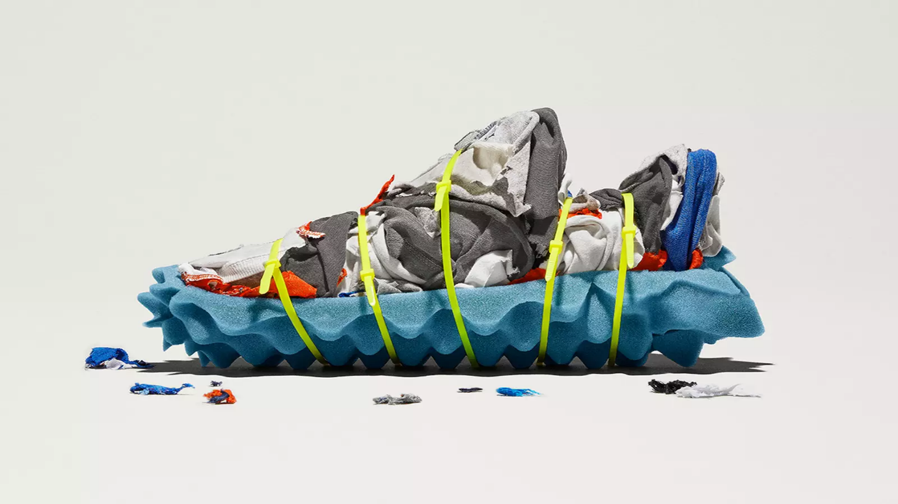

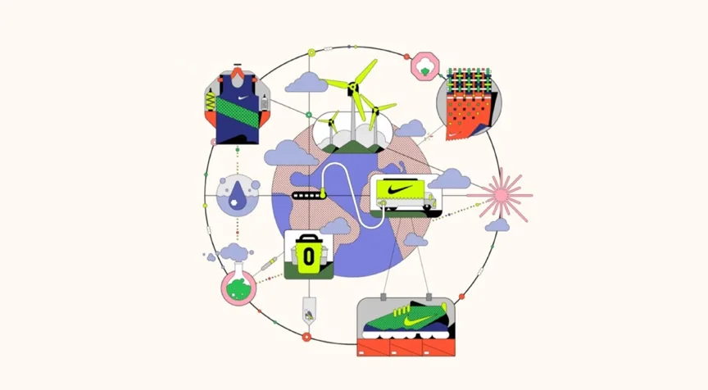

**Conclusion**

It was a wonderful and learning experience for me while working on this project. Lot of things I have analysis while doing project about ***“Meta*** ***and “Nike”***.

After comprehensive analysation of ***“Meta” and “Nike”***, It is evident that both companies are influential players in their respective industries with distinct approaches to innovation, branding, and corporate strategy.

Meta, formerly known as Facebook, has evolved beyond its origins as a social media platform to became a multifaceted technology, with a focus on virtual reality, augment reality and other emerging technologies. The company’s ambitious vision for the metaverse presents numerous opportunities for immersive, experience, digital connectivity, and Noval forms of interaction.

On the other hand, Nike is a global leader in the athletic footwear, apparel, and equipment industry renowned for its iconic brand, innovative product design, and marketing prowess. Nike’s commitment to performance, sustainability, and inclusivity has helped in maintain a strong competitive position and a loyal customer base worldwide.

***Thank you***